Abstract
Data mining is the process of finding previously unsuspected patterns in information contained in large database. Hence, in this seminar work a Data Mining Based Analysis of Students Academic Performance that is capable of analyzing the students academic performance in making effective analysis on Students Academic Performance of Computer Science in Osun State Polytechnic, Iree was designed, implemented and evaluated.
The developed system was designed by creating the following modules: Home Page, ND registration Page, HND registration page, ND result analysis page, ND grade analysis page, HND result analysis page, HND grade analysis page, ND combine report and HND combine report of the Data Mining Based Analysis of Students Academic Performance. The system was implemented using visual basic 6.0 programming language. The evaluation of the performance of the developed system was carried out by administering questionnaires on 60 users of the system based on usability and speed of processing.
The results of the evaluation of the developed system showed that 45 out of 60 users agreed that the system is easy to use. Also 50 out of 60 users agreed that the system is fast while 10 users disagreed. Thus a Mining Based Analysis of Students Academic Performance that is capable of easily and speedily assist on making tangible analysis on students academic performance has been developed in this seminar work.

- Introduction
Data mining is the process of finding previously unsuspected patterns in information contained in large database. The major reason why data mining has a great deal of attention in the information industry in recent year is due to the wide availablility of high amount of data and the information and knowledge gained can be used for application ranging from production controls and market analysis business management engineering design and science exploration (Amazon, 2005). Data mining can be viewed as a result of the natural evolution of information tehnoolgy because before 1960 when database and information technology had not evolved analysis of data was basically the primitive file processing which could not give the appropriate useful information despite the huge amont of the time consumed the evolutionary path of data mining as been witnessed in the database industry in development of the following databased and information technology are data collection and database creation, data management (including data warehouse and data preparation) and data analysis and understanding (involving data mining and data interpretation) (David reilly,2004).
Moreover data mining is also known as Knowledge Discovery in Database (KDD). Consequently data mining consist of more than collection and managing data, it also include analysis and predictions (Anderson, 2006).
It is a research area at the intersection of several disciplines, including statistics, database, pattern recognition, neural network, visualization, optimization, and high-performance and parallel computing. With the success of database systems, and their widespread use, the role of the database expanded from being a reliable data store to being a decision support system (DSS) (David reilly,2004).
Data mining simply refers to extracting or “mining” knowledge from large amount of data. It is the process of finding correlations or patterns among dozens of field in large relational database. Data mining is unlike a data only perform data or information retrieval, or that performs deductive query answering in large database, but it combines machine learning, high performance computing, pattern recognition, neural networks, data visualization, information retrieval image and signal processing and spatial data analysis (Frawley, 1992).

1.1 Background to the Study
Presently, the Data Mining Based Analysis of Students Academic Performance of Computer Science Department in Osun State Polytechnic, Iree employs the manual approach in analysis of students’ academic performance. Such analyses are made by deliberating on the analysis of students academic performance carried out on student results. This approach as been found to be associated with problems scuh as curmbsome, time wasting and eventual delay in analysing of students’ academic performance.
Hence, there is a need to develop an automated system that is capable of assisting the management in making timely data mining based analysis of students’ academic performance of Computer Science Department in Osun State Polytechnic, Iree.
1.2 Statement of the Problem
Investigation has revealed that there is no automated system of analysis of student academic performance made on processing Data Mining Based Analysis of Students Academic Performance of Computer Science Department in Osun State Polytechnic, Iree.
Hence, in this seminar work a Data Mining Based Analysis of Students Academic Performance that is capable of analysing the students academic performance in making effective analysis on Students Academic Performance of Computer Science Department in Osun State Polytechnic, Iree was designed, implemented and evaluated.

1.3 Aim and Objectives of the Seminar
The seminar is aimed at developing a Data Mining Based Analysis of Students Academic Performance of Computer Science Department in Osun State Polytechnic, Iree.
The specific objectives of the work include:
i. To design a Data Mining Based Analysis of Students Academic Performance of Computer Science Department in Osun State Polytechnic, Iree.
ii. To implement the designed system in (i) above using Visual Basic programming language and Microsoft access for the database.
iii. To evaluate the performance of developed system by compazering it with the existing approach of Analysis of Students Academic Performance.

1.4 Significance of the Study
The implementation of Data Mining Based Analysis of Students Academic Performance is very significant and relevant in any academic institution where record of each student has been collected and stored in a databased system the need for data mining in analysis of students academic performance.

1.5 Scope of the Study
The seminar is aimed at creating a very good Data Mining Based Analysis of Students Academic Performance that will ease the work of the management of the school and allow the effectiveness of a good analysis of students academic performance designed.
1.6 Research Methodology
The methods used for caring out the seminar work are as follows:
i. An establishment of a theoretical foundation for the seminar work through a sound review of relevant literatures on Data Mining Based Analysis of Students Academic Performance of Computer Science Department in Osun State Polytechnic, Iree.
ii. The design of Data Mining Based Analysis of Students Academic Performance of Computer Science Department in Osun State Polytechnic, Iree.
iii. The implementation of the designed system in (ii) above using Visual Basic Programming Language and Microsoft access for the database.
iv. Evaluation of the performance of the newly developed system based on accesibility and usability of the system.
1.7 Definition of Terms
Data mining: is the process of finding previously unsuspected patterns in information contained in large database.
Record: A thing constituting a piece of evidence about the past, especially an account of an act or occurrence kept in writing or some other permanent form.
Registration: The action or process of registering or of being registered.
Database: It is an organized collection of data for one or more purpose usually in digital form.
Data: Are the basic facts about an entity which have no special meaning until they are process and transform into information.
File: Is the collection of organized related records.
Student Bio-Data: This can be a particular of each student e.g. sex, date of birth, etc.
Ill-Structure Problem: means the way by which some portion of record is being disarranged or disorganized.
Discovery in Database;- is the process of identifying valid, potentially useful and ultimately understanding structure in data
Client: can send a query to server the client could run on personal computer.
Data Administration System;- help users manage the overall database environment by providing facilities for backup and recovery, security managemnt query optimization, concurrency control and change management
Support: This helps the committee and encourages them by saying or showing that the user has agree with them.
System: This is group of component that function has an operating system. It accepts data manipulate it and produce it output.
Distributed Database System: It offers many advantages compared to centralized database system and manual system of record keeping.
A Database Management System: A collection of program that enable users to create and maximize database.

- Literature Review
2.1 Introduction
Data mining (sometimes called data or knowledge discovery) is the process of analyzing data from different perspectives and summarizing it into useful information as more data is gathered with the amount of data doubling every three years, data mining is becoming an increasingly important tools to transform this data information it is commonly used in a wide range of profiling practices such as marking surveillance fraud detection and scenic discovery. (Filo,1982).
Data mining can be used to uncover patterns in data sample. It is important to be aware that the use of non-repesesentative sample of data may produce results that are not indicative of the domain. If those patterns are not present in sample being “mined” there is tendency for insufficiently knowledgeable “customers” of the result to attribute magical abilities to data mining, treating the techniques as a sort of all seeing crystal ball (Sgelio, 1992).
Although data mining is a relatively new terms; the technology is not for many years. Business scientists and government have used powerful computer to sift through volunes of data such as airline passenger trip records census data and supermarket scanner data to producer market reseach reports (note, however, that reporting is not always consider to be data mining). (Solio,1985).
However continuous innovations in compuer processing power disk storage data capture technology; algorithms methodologies and analysis software have dramatically increased the accuray and usefulness of the extracted information(David reilly,2004).

2.2 Result Validation of DataMining
The final step of knowledges discovery from data is to verfy the patterns produced by the data mining algorithms occur in the wider data set. Not all patterns produce by the mining algorithms are necessary valid it is common for the data mimning algorithms to find tranining set which are not present in the general data set, this is called over fitting to overcome this the evalution uses a test set of data which the mining algorithms was not trained on. A number of statistical methods may be used to evaluate the algorithms such as ROC curve(Sprague,1982).
If the leant patterns do not meet the desired strandard, then it is necessary to revaluate the preprocessing and data mining. If the leant patterns meet the desired standards then the final step is to interpret the leant parttern and turn them into knowledge(David reilly,2004).
The time consumption during the process but later with the aid of software application programs, the computer became useful in so many areas of specialization for instance von Neumann went in to research in order to develop a machine that is able to store information which is still utilized till today(Carlson,1982).
As the use of computer begine to advance, people begine to reason to store large information such as record, files, picture, and audio on the computer and later updating the stored information, this lead to the development of the file structure concept(Sprague,1982).
Information can be stored for future purpose in so many ways and the methods of storage advances time to time because of large accumulation of data being collected which required memory space to collect such data information can be stared on flash drives, magnetic disks, hard and floppy disks(Sprague,1982).

3.0 Research Methodology
3.1 The Research Approach
The methods used in carrying out the seminar work are as follows:
i. The design of the developed system
ii. The Implementation of the developed system.
iii. The Evaluation of the performance of the developed system.
3.2 Description of the Developed System
The developed system was designed by creating the following modules: Home Page, ND registration Page, HND registration page, ND result analysis page, ND grade analysis page, HND result analysis page, HND grade analysis page, ND combine report and HND combine report of the Data Mining Based Analysis of Students Academic Performance are shown bellow:
3.2.1: Home Page: This an Introduction page of the system where user can access the system as shown figure 3.1.
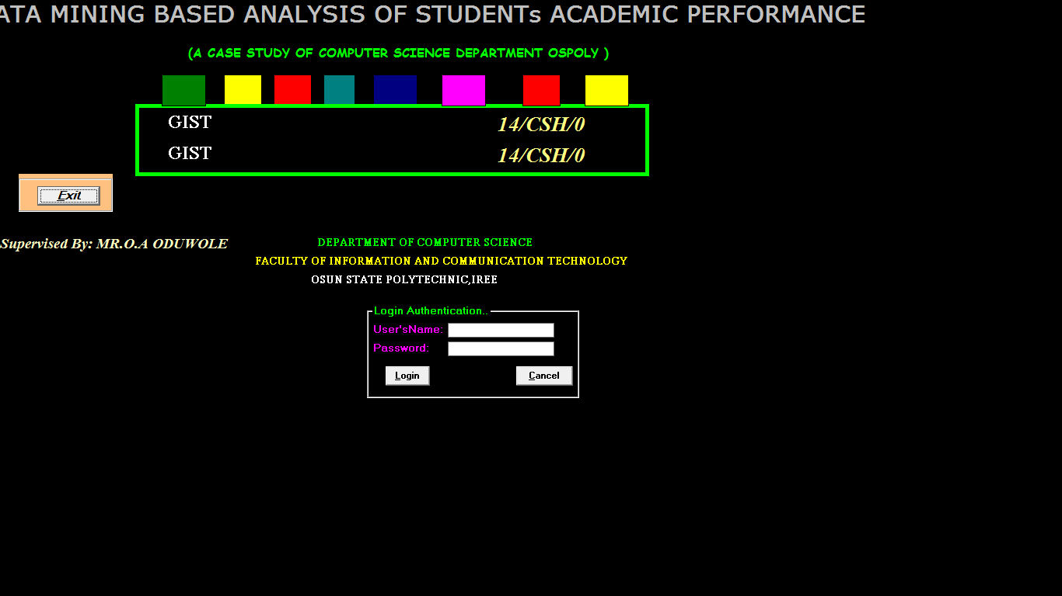
Figure 3.1: Home Page of the Data Mining Based Analysis of Students Academic Performance

3.3 System Implementation
The system was implemented using Visual Basic 6.0 while Ms-Access is used as the Database and Macromedia Fireworks will be used in designing the input and output interface because of the following:
i. It is user friendly.
ii. Visual basic provides a comprehensive interactive and context-sensitive online help system.
iii. Visual basic coordinate with third party vendor product.
iv. Its flexibility.
v. Its simplicity.
The phase is the most vigorous and time consuming part. It is found that any error occur is corrected here.

3.4 Evaluation of the Developed System
3.4.1 Evaluation Criteria
Evaluation of the developed system was carried out based on the following criteria:
i. Usability
ii. Speed

4.0 Result and discussion
4.1 Results
The results of the evaluation of the developed system are as presented in tables 4.1, 4.2 and figures 4.1 and 4.2.
Table 4.1: Responses of users on usability of the developed system
The developed system is easy to use | Frequency | Percentage
Strongly Agree | 30 | 50%
Agree | 15 | 25%
Disagree | 10 | 16.67%
Strongly Disagree | 5 | 8.33%
Total | 60 | 100%

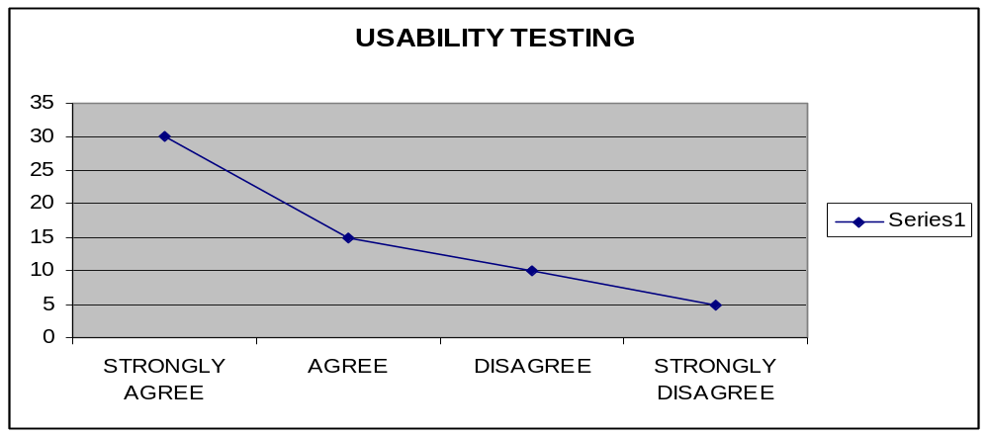
Figure 4.1 Graphical Representation of Reponses of the users on Usability of the developed system

  - Discussion
The results of the evaluation of the developed system showed that 45 out of 60 users agreed that the system is easy to use. Also 50 out of 60 users agreed that the system is fast while 10 users disagreed.
Hence, this that shown a good majority of the respondent that made use of the system find it to be user friendly and fast in operation.

5.1 Conclusion
In this seminar, a Data Minig Based Analysis of Students Academic Performance was designed and implemented using Visual Basic 6.0 Programming language. The developed system was also evaluated based on accessibility and usability of the system.
It is therefore concluded that a Data Mining Based Analysis of Students Academic Performance that is capable of providing a user friendly and accessible means of students academic performance has been developed.
Thereby, establishing the fact that objectives of the work has been achieved.

5.2 Recommendation
It is recommended for further studies that the developed system be improved to provide in on-line access for Data Mining Based Analysis of Students Academic Performance.

References
Amazon. Com (2005). An overview of Data Mining Techniques retrieved ocotber 27 2006 from http:// www. Amazon com /exex/obidos.htm.

Anderson U. (2006). Data Mining what mining, retrieved December 17, 2006 from
http:// www.anderson.ucla.edu/facult/teacher/technologies/palace/datamining htm.

Bing, L. (2007). Web Data Mining: Exploring Hyperlinks, Contents and Usage Data. Springer,
ISBN 3-540-37881-2.

David reilly (2004). Data migration techonology and its implication.Retrived noverber 20,
2006 from http:// www.davideilly com /topies/ software agents

David reilly (2005). Data Migration Techonology and its implication.Retrived April 8,
2007 http:// www. Jmp.com/ads/adwords/ stagahic com

Fayyad U,.M piatesky Shapiro g and smyth p. (1996). From Data Minng to knowledge
discovery in database.

Frawley, W., Piatetsky-Shapiro, G. and Matheus, C. (1992). Knowledge Discovery in
Databases. AAAI/MIT Press.

Fredrick, R. (2003). The Text Mining Handbook. Cambridge University Press, ISBN 978-
521- 83657-9.

Filo W.D(1982). Data Mining (Sometimes called data or Knwledge discory) is the process of analysising data from difference perpectives and summarizing.

Hand, D., Mannila, H. and Smyth, P. (2001). Principles of Data Mining, The MIT Press.

Jones(1980). Identity all input data to the software and organize in a hierarchical manner.

Macro, C. (2001), Mastering Viaul 6.0 USA sybex incorporation.

Stasoft (2005). An Introduction to Data Mining retrieved December 21,2006 from
http:// www. Stasoft. Com/textbook/glosd. Html

Sgelio E.F(1992). Data Mining can be used to uncover patterns in data sample.

Solio G.W(1985). Although Data Mining is a relatively new terms.

